The upgrade to the EAST poloidal field power supply monitoring system
Lili Zhu, Liansheng Huang, Peng Fu, Shiying He, Guanghong Wang, Xiaojiao Chen, Zejing Wang, Lingpeng Li

Abstract
This paper presents the architecture and the implementation of the upgraded Experimental Advanced Superconducting Tokamak (EAST) Poloidal Field Power Supply (PFPS) monitoring system. To meet the requirements of EAST long pulse discharge, the monitoring system has been upgraded based on experimental physics and industrial control system (EPICS) and MDSplus. It provides an integrated management of supervision, data acquisition and real-time control. The program is flexible and portable, which improves the system performance. The I/O interrupt mechanism of the device support module is used to read the updated data, which reduces the network communication load. Asynchronous Driver Support (AsynDriver) is used to develop the device's specific interfacing code for the DAQ card driver, simplify writing of drivers and make the program more reliable. The HMI is developed using Control System Studio (CSS). During the experiment, the collect data is stored in the archiving system from PFPS system and sent to the MDSplus data server at the same time, so that the operator can view and analyze the online data and offline data. The upgraded monitoring system provides a general design scheme, which can be well integrated into the control system. The experimental results show the system realizes the remote operation and monitoring of equipment of PFPS and provides a friendly human-machine interface, supports multiuser operation.

Keywords
EAST，Poloidal field，I/O interrupt，Asyndriver

1. Introduction
With the development of nuclear fusion experiment, it is inevitable to enter long pulse discharge. In order to obtain high discharge parameters, the experimenters need to adjust the corresponding parameters by the monitoring system according to the changes of the important diagnostic signals in the experiment process. But the self-developed monitoring system gradually exposed a lot of problems in maintenance, real-time display, alarm and log. EPICS software framework [1] is a distributed control system which has been successfully applied in fusion devices at home and abroad. EPICS has been used in KSTAR data acquisition system in South Korea. The developer does not have to be concerned about the specifics of the local system, but can concentrate on the implementation of the control logic [2]. ITER CODAC system uses the EPICS framework to develop I&C and uses channel access (CA) protocol to realize data interaction [3]. CA protocol, an access mechanism established on the basis of TCP/IP protocol, provides the application interface between the Operator Interface (OPI) and Input / Output Controller (IOC) [4]. Due to the good scalability and open source of EPICS, EAST adopts it to develop the central control system [5].
The EAST is the first tokamak equipped with both poloidal field and toroidal field coils capable of superconducting operation [6]. As shown in Fig. 1, a set of EAST poloidal field power supply consists of AC/DC converters, bi-direction external bypass, Switching Network Units (SNU), and Quench Protection (QP) circuits [7]. Each converter operates in four quadrants to gradually ramp up and control the current, to produce the requested plasma shape and position [8]. The reliable performance of the EAST poloidal field power supply system is crucial for the physical experiments. The previous monitoring system was developed on a Windows XP operating system and it did not support the EPICS, making it incompatible with the EAST control system. Moreover, in the previous DAQ system, several important control parameters were not monitored during the experiment and, most importantly, an alarm was not sent immediately when an exception within the program occurs, making it difficult to pinpoint the fault on time. Thus we propose an upgrade to support a reliable long pulse EAST operation. The system was developed based on EPICS, a set of freely licensed software tools to develop distributed control and acquisition systems. The EPICS software package contains three layers, namely the IOC, CA Protocol, and the OPI. The distributed database (DB) system is loaded in the IOC. A lot of EPICS records are configured in the DB to store the real-time data between the devices. The device support is the interface between the DB system and the devices. The CA server publishes Process Variables (PVs) to the EPICS network. Multiple CA clients, such as the operator interface clients, alarm systems, and archive systems, shall access the published PVs whenever it is required [1].
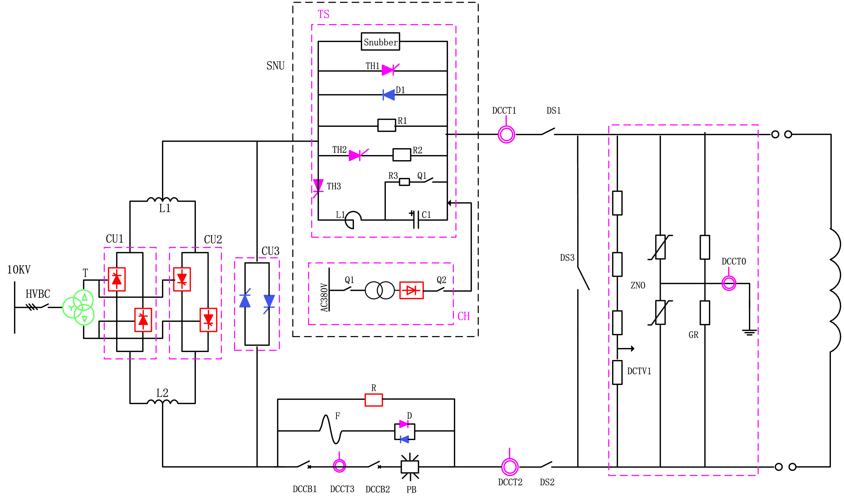
Fig. 1. The architecture of a set of EAST PFPS.

2. The architecture of upgraded monitoring system
The upgraded monitoring system should be compatible with the current EAST data system, which is a distributed, online, and scalable system. Fig. 2 shows the hardware structure of the upgraded DAQ system that consists of the DAQ nodes and the server. The DAQ nodes are installed on the three different floors of the EAST building and they are operated to collect the data from the control voltage, the signals on the AC side, and the signals on the DC side. The DAQ nodes are based on the PXI platform and equipped with NI PXIe-8115, 2.5 GHz dual-core Intel Core i5–2510E processor, 2 GB memory, and dual Gigabit Ethernet. The PXI-6255 DAQ cards manufactured by NI are multiplexed data acquisition boards and they were chosen to acquire the data generated by the device because of their accuracy and high sampling frequency. Each PXI-6255 card can acquire the signals from 80 single-ended channels with 16-bit resolution at a maximum DAQ frequency of 1.25 M samples per second (SPS). Then, the experimenters set the control signal on the server's man-machine interface. Upon receiving the control signal, the master sends the clock and trigger information to the DAQ nodes via PXI6683. The clock and trigger of each DAQ node are synchronized through a PXI-6683 card capable of synchronization conforming to the IEEE 1588–2008 standard [9]. The DAQ system is based on the PXI industrial standard and is installed on a 64-bit Linux operating system. The man-machine interface is at the top of the monitoring system, which is developed by CSS. The server is developed based on MDSplus, which stored data online.
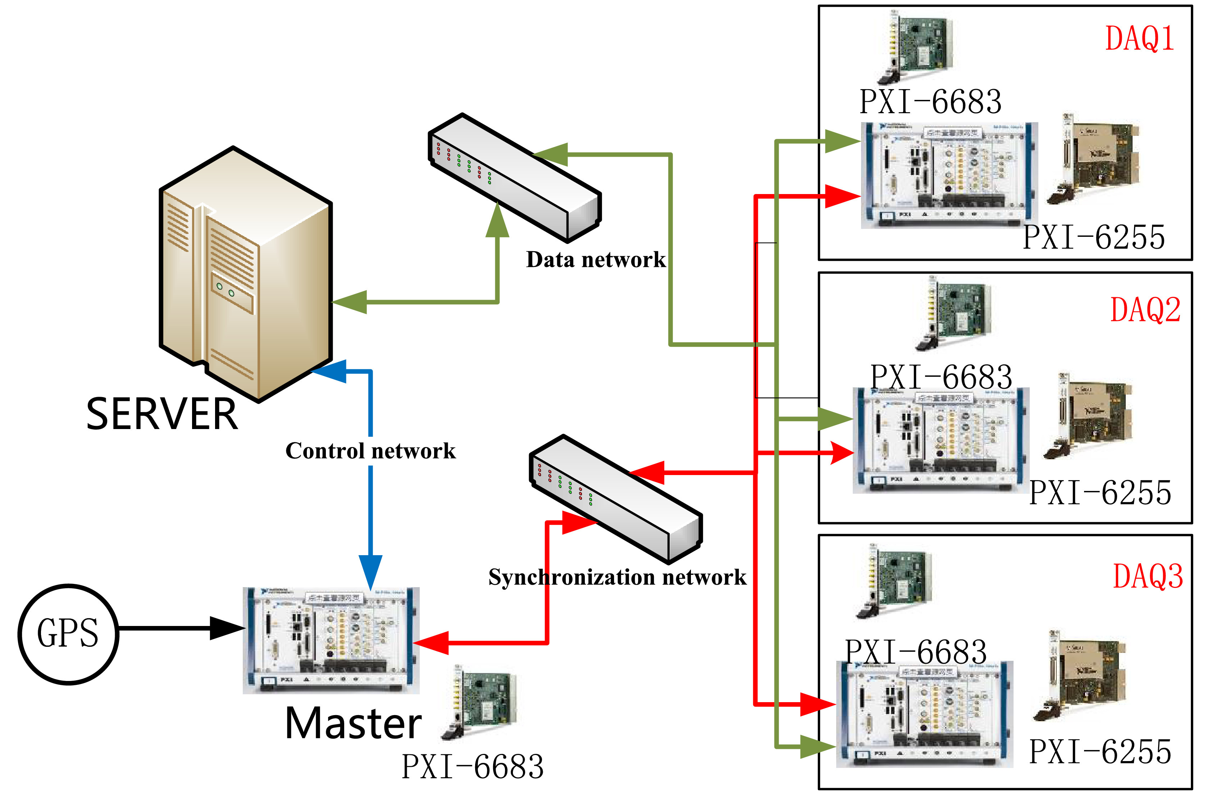
Fig. 2. The hardware structure of the upgraded DAQ system.

3. The program design of upgraded monitoring system
The DAQ system framework based on EPICS is shown in Fig. 3. The operator sends control commands (sampling rate, start/stop signal, and so on) to the DAQ nodes by the OPI and monitors the status of the computer via the OPI. The communication between the server and the collection node is based on UDP protocol. The IOC sends the data of time-slice to the server in real time and the server creates two threads to receive the data which is stored in MDSplus database. Meanwhile the data is stored in EPICS database. The concept of “time-slice” is that the plasma discharge process is divided according to the fixed period Ts (the time-slice length).
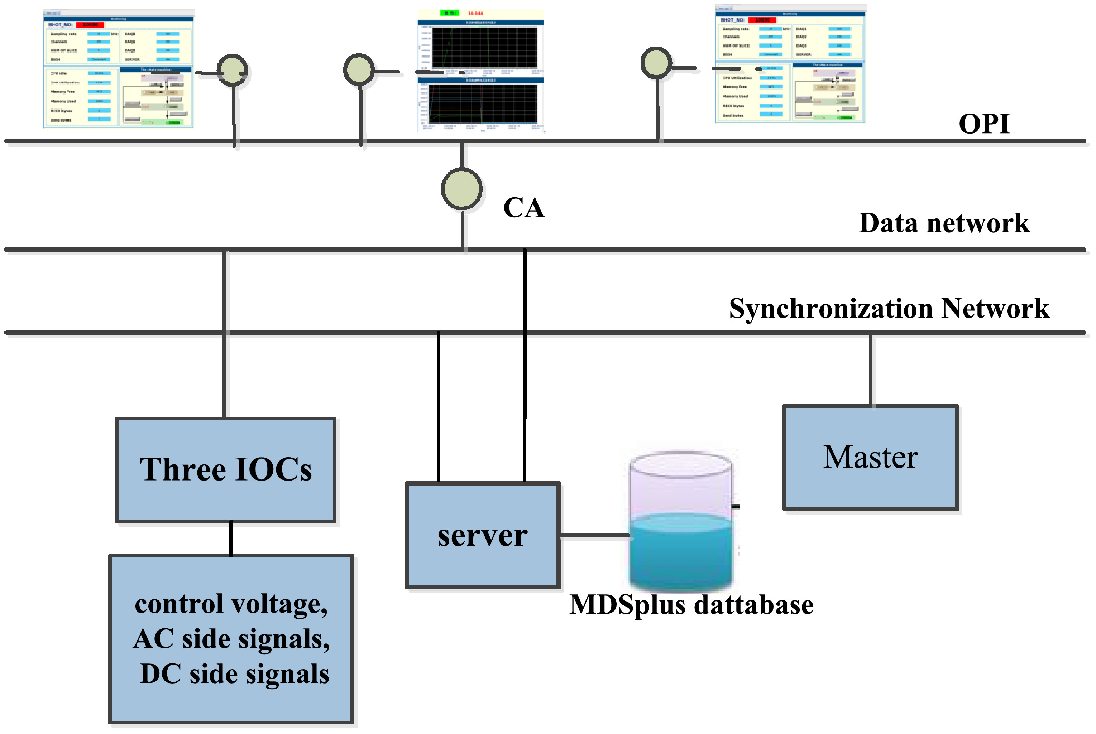
Fig. 3. The DAQ system framework based on EPICS.

3.1. EPICS database
The core module of EPICS is the distributed real-time database [1], in which the database records the communications between the OPI clients via the CA and the communications between the OPI clients and the lower hardware via the record support, the device support, and the driver. The records types are Analog Input (AI), Analog Output (AO), Binary Input (BI), Binary Output (BO), Multi-Bit Binary Input (MBBI), and Multi-Bit Binary Output (MBBO). EPICS supports various scanning mechanisms including cycle scanning, passive scanning, and I/O interrupt. The database stores numerous records, such as the system status, the collection status, the transmission status, and the control command. The records description is listed in Table 1.

Table 1. The records description.
Record | Scanning mechanism | Description
AI | I/O interrupt | Collecting data
AO | Passive | The sample frequency
AO | Cycle scanning | Channel availability check
BO | Cycle scanning | The trigger source
MBBI | Cycle scanning | The state of state machine
MBBO | Cycle scanning | The state request
AI | Cycle scanning | CPU utilization
AI | Cycle scanning | Memory utilization
AI | Cycle scanning | The data of time-slice

The record configuration to store the data from the driver is shown below. As an example, the sample frequency record is defined as follows:

record(ao,"$(HOST):$(PortName): frequency ")
{
field(PINI,"NO")
field(SCAN,"Passive")
field(DTYP,"asynInt32")
field(OUT,"@asyn($(PortName),0) sample_frequency")
field(EGU,"Hz")
}

3.2. The communication protocol
The EPICS private network is based on Ethernet and the messages are transferred via CA protocols, which are the standard protocols in control systems. When we need to read a certain record's value, the CA clients shall, by default, broadcast a name search request to the UDP on the subnet. Given the IOC is running on a computer on that subnet, it should receive at least one of those search requests. The server and the client shall then establish a TCP connection and the data is exchanged in the data network.
However, the MDSplus database server applied in the EAST poloidal field data management system does not support EPICS. Consequently, it cannot communicate with the DAQ nodes via the CA protocol, thus the socket is used to provide the data transfer service between the DAQ nodes and the MDSplus database server . There are two common communication protocols in the transport layer: UDP and TCP. UDP is an unreliable, connectionless protocol that provides a very simple service for the application, whereas TCP is a connection-oriented protocol that allows packets to be sent from one machine to others on the internet without transmission error. Firstly, the data collected by the DAQ nodes is mainly used for offline analysis and online monitoring, and the real-time requirement is not high. For example, online monitoring function, which is mainly to provide experimenter to observe data during the experiment. When the refresh speed of the HMI exceeds 24 frames per second, the human can observe the continuous picture. Therefore, the period of collecting and sending data is less than 40 ms. The difference of data transmission delay between TCP / IP protocol and UDP protocol is almost negligible during the period. Secondly, UDP protocol will cause packet splitting and packet grouping in the link layer, which increases the probability of network packet loss. Software also needs to add a lot of design to prevent network packet loss. TCP is a connection-oriented protocol with the function of "three handshakes" in data communication, so there is no packet loss. TCP / IP protocol also adopts stream data communication, which is very suitable for transmitting a large number of continuous data. Therefore the TCP protocol was chosen.
The MDSplus database server determines the accuracy of the received data by evaluating the header of the TCP packet. Then, another thread is created to determine if the DAQ node and the MDSplus database server have become disconnected. If the communication is disconnected, the MDSplus database server status record is set and displayed on the Operator Interface (OPI) to inform the operator about the server status. Simultaneously, a message is sent to the message queue that mainly takes a note of the shot number and marks that the data has not been transmitted. The data is saved on the local hard disk until the connection is reestablished and the remaining data is transferred to the server.

3.3. I/O interrupts in the device support module
EPICS supports various scanning mechanisms, three of which are implemented in this paper, namely: cycle scanning, passive scanning, and I/O interrupt. The I/O interrupt scanning mechanism supports both hardware interrupts and software-generated events. The initial objective of the I/O interrupt scanning mechanism is to request for record processing when a hardware interrupt occurs. The long-pulse experiments require a large amount of data to be collected and the IOC to constantly check the I/O device [10]. Originally, the IOC can only complete one task at a time, however, using the I/O event, the IOC may be informed via I/O interrupt when the I/O device can be accessed completely. Software interrupts are used to read the two buffer data of the record field in the upgraded DAQ system. Over 200 signals with a 20 kHz sampling rate from various front-end sensors were collected, however, the scanning mechanisms of EPICS does not support such fast data update. To solve this issue, the data has a process of down sampling rate and is recorded by the EPICS database by the I/O event. When device support receives the I/O interrupts signal, the received data is record in DB. Meanwhile, all data is sent to the MDSplus database. The overall trend (waveform) of the data is displayed in the OPI at a relatively high speed.

3.4. asynDriver design
The hardware driver of the NI PXI-6255 board being delivered by National Instruments. The software driver framework is mainly composed of device support and driver support which is shown in the Fig. 4. In the monitoring system, there are six DAQ cards. The standard EPICS interface between the device support and the drivers is loosely defined, so custom device support is required for each DAQ card. However, the distributed system complexity in handling multiple drivers increases as each driver has different device support. This complexity issue was one of the main concerns that led to the use of asynDriver. asynDriver [1] is a general-purpose tool for interfacing device-specific code to low-level drivers; it is essentially a driver framework. The asynDriver began as an effort to unify the support for asynchronous devices (such as RS-232, IEEE-488, and Ethernet sockets), and recently, it has been extended to be equally applicable for synchronous devices. The asynDriver provides the common functionalities of most drivers, including the generic device support for various standard EPICS records.
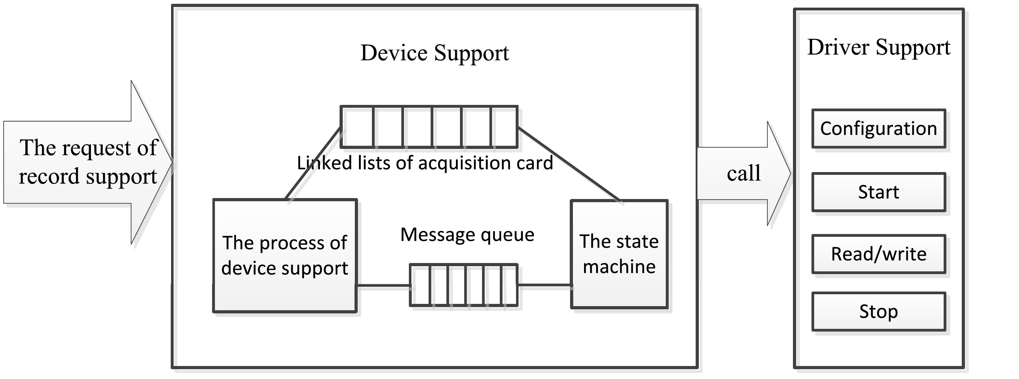
Fig. 4. The software driver framework.

The DAQ software is written in the C programming language and runs on a Linux computer with multithreading capability. The program of the NI PXI-6255 asynDriver is shown in Fig. 5. First, the record processing calls the device support. Then, the asynOption interface for the NI PXI-6255 reads or writes the configuration parameters (such as IP, port). After the read/write operation is complete, the asynInt32 and asynFloat64 are used to read/write the analog data. The ASYN Driver uses its configuration file to configure, start, and stop the DAQ cards, accordingly, to acquire the data. When the DAQ cards finish collecting the data, a new process thread is created to processed and sent the data to the MDSplus database. To store each time-slice of the data, a double buffer mode was employed. Due to the large amounts of data transferred to the server, we implement direct memory access (DMA). DMA is a very useful method to save the CPU power that can be used for higher priority tasks instead of copying data. During initialization, the program creates a thread to collect the data, then two buffers are opened up (buffer[0] and buffer[1]) and the PXI-6255 cards are initialized and registered. When the First In First Out (FIFO) buffer in the PXI-6255 card is full, the data is directly transmitted to the buffer[0] through DMA and when the buffer[0] is full, the data is transmitted to the buffer[1]. Simultaneously, another thread is created to check whether the two buffers are full, and if they are full, then the data is transferred to the server. The above steps are repeated until the DAQ finishes.
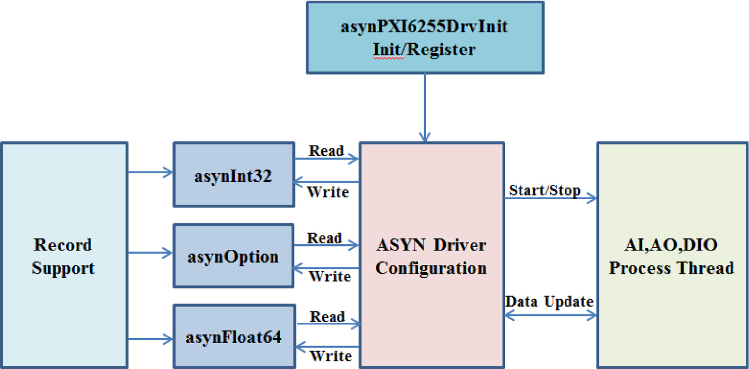
Fig. 5. The program of asynDriver of the NI PXI-6255 card.

3.5. The state machine design
The DAQ node executes a finite state machine to continuously acquire and transmit data [11]. The whole process is performed in a cycle: the DAQ node receives state request commands via PV, performs some individual steps, and then publishes and observes their state (Off, Ilde, Ready, Running), also via PV. The program for the finite state machine was developed using the state notation language (SNL), which provides a simple yet powerful tool for programming sequential operations in a real-time control system. The sequencer in EPICS provides services to the program, such as establishing the connections to PV and handling asynchronous events. PVs represent the current status and state requests using the MBBI and MBBO record types since the common use of MBBI/ MBBO record is to read/write contiguous, multiple bit inputs/output from the hardware.
First, the finite state machine starts in the idle state. When the DAQ node receives the configuration information from the console via the CA protocol, the initialization process of the DAQ cards (card numbers, channel numbers, and sample frequency) is started. The sampling frequency is significantly higher than the recording frequency, meaning that the data is not recorded for every sample, and the DMA initialization pre-assigns a memory block. Then the finite state machine moves to the ready state and waits for a trigger. When the trigger arrives, the finite state machine moves to the running state. In the running state, the data is collected using a double buffer mode and sent to the server in a real-time manner.

4. OPI design
We developed the OPI based on the Control System Studio (CSS). The CSS, which is based on the RCP Eclipse framework, which was developed in the Java programming language. The CSS has the advantages of being portable, easy to operate, rich man-machine interface features, etc. [12]. The CSS satisfies the needs of the monitoring system very well and it has been widely used in fusion experiments. The HMI, an integral part of the control system, was developed in CSS Best OPI Yet (BOY). An OPI includes the widgets (or controls), that are the elements of the graphical user interface (GUI). The widgets display and manipulate the information according to the user's configuration. For example, a label widget displays various messages and a text input widget is used to change the PV value. The CSS BOY can also be easily connected to the data source via the CA protocol. If the functions cannot be directly allocated in the BOY, the users are allowed to use Java or Python scripts to configure their own rules. In general, BOY can create very rich and varied GUIs. Fig. 6 was developed and implemented using the CSS BOY, which can send commands to the IOC and monitor the parameter status for visualization.
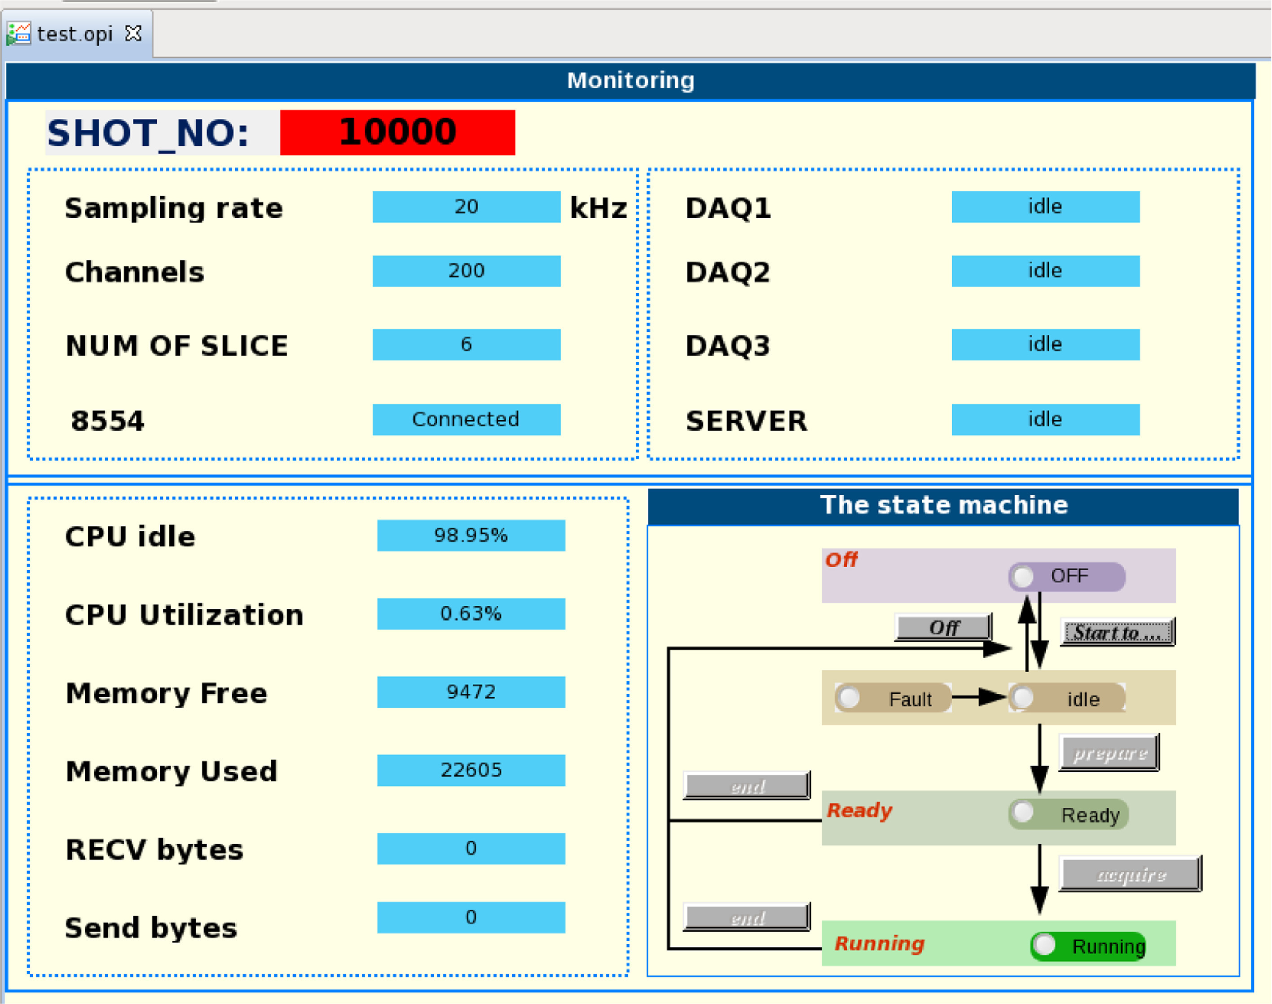
Fig. 6. OPI of the DAQ system.

5. Test and results
The monitoring system proposed in this paper has been thoroughly tested and it achieved promising results. It has been, and is currently, implemented on an active server in the EAST PF control system from the 2019 EAST campaign until now. Fig. 7 showed the PVs according to the voltage and current, which are both stored in the EPICS records and displayed on an XY Graph widget in the OPI in a real-time manner. Fig. 8 showed the voltage and current data stored in the MDSplus tree file, displayed by web-scope [13]. However, the web-scope does not display the data completely nor as reliably as the OPI developed using the CSS BOY. The lower right box of Fig. 8 showed the state machine while the remaining three boxes showed the real-time values and states of the DAQ system, such as the sampling rate and the memory usage. Also, it is possible to not only monitor, but also change certain important control parameters or even the program sequence, during a physics experiment.
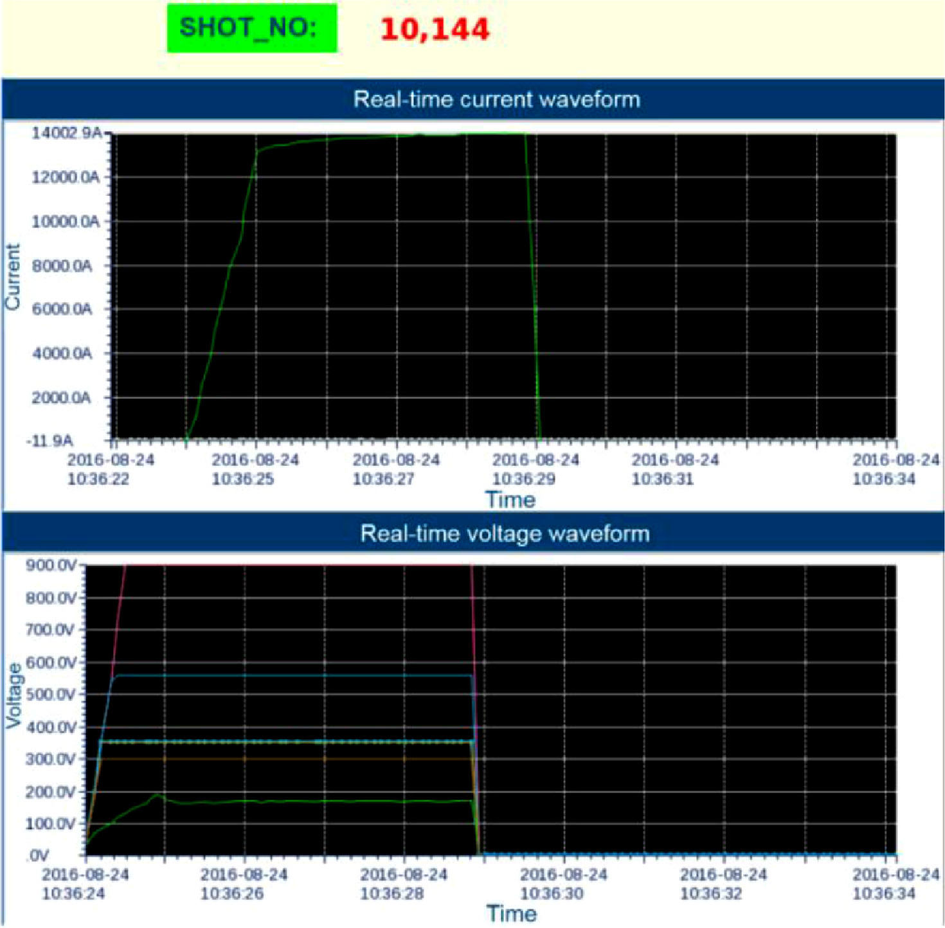
Fig. 7. Real-time display of the current and voltage waveform through the operator interface.
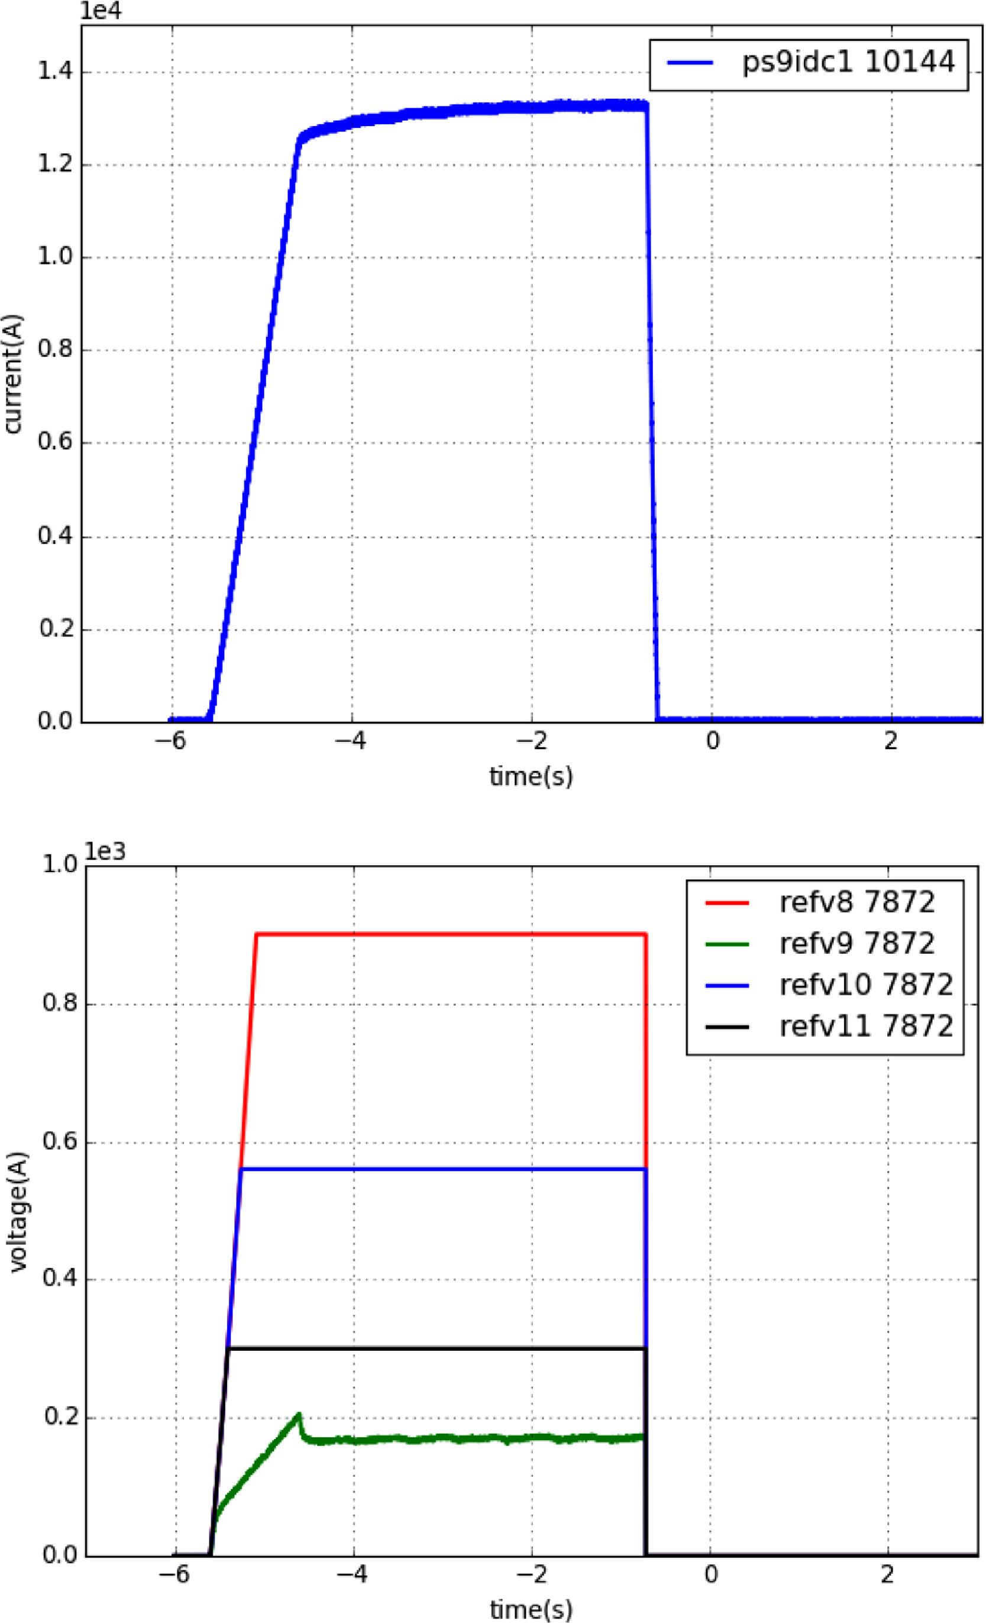
Fig. 8. The current and voltage waveform displayed in the web-scope.

6. Conclusion
The upgraded EAST PFPS monitoring system was designed based on the EPICS framework and MDSplus. Different communication protocols are adopted to realize the data interaction between the cross-platform systems. several novel and useful technologies and methods such as the asynchronous device support, the asynDriver, and the state machine, were used to make the software more reliable and flexible. The combined use of EPICS and MDSplus is widely used in fusion, but their integration will be new in EAST PFPS. The upgraded monitoring system not only realizes the long pulse data acquisition, storage, and publication, but also integrates the online monitoring of essential parameters. In the future DAQ will support real-time network to further improve the performance.

Declaration of Competing Interest
The authors declare that they have no known competing financial interests or personal relationships that could have appeared to influence the work reported in this paper.

